Questionnaire for annual and semi-annual reports

Name orangutan: Janet

Current housing/cage | Sozialization Cage
Age | 4,7 Years Old
Current state of health / any particular health issues | During a rigorous routine physical examination conducted by the keeper team after her activities, a pig louse (Haematopinus suis) was found on Janet’s left eyelid, which had caused slight swelling and discomfort. The medical team acted quickly to carefully extract the tick, followed by an intensive observation period of more than 24 hours to monitor for potential irritation or excessive itching. Monitoring results showed that Janet was in excellent condition without requiring further medical intervention, and she has now fully recovered and is ready to continue her learning adventures under full supervision in the field.
Progress over the past 3 months | Janet continued to make good progress at the Forest School and remained highly active throughout daily activities. She spent much of her time travelling and feeding in the canopy, showing a strong arboreal tendency at heights ranging between 5 to 20 meters above the ground. Janet moved confidently through the trees using various locomotion techniques, including bridge locomotion, climbing, sitting on branches, and vertical ascent and descent. She was also observed using multiple supports, including larger branches, while navigating through the canopy.  Janet demonstrated strong feeding motivation and showed particular interest in natural food sources available at the Forest School. During this period, she consumed a large amount of figs and appeared highly skilled at locating preferred fruiting trees. However, staff often observed Janet feeding on unripe figs, rather than the ripe ones. Figs are a well-known food source for Sumaran orangutans in the wild, as it is available throughout the year. Early exposure to this staple food source is great for rehabilitated orangutans in accustomizing with natural food sources.
Particular events or progress | While Janet continued to display social tendencies, she also showed growing confidence and independence within the Forest School environment. Her increasing activity in the canopy and improved ability to locate natural foods represent positive developments in her rehabilitation progress.
Special relationship to any fellow patients (friendships, conflicts, etc.) | Socially, Janet remained interested in interacting with other orangutans. She was frequently observed playing with Candra and Matang during Forest School sessions. However, Janet still occasionally displayed cautious behavior around Siska and would sometimes avoid or move away from her during encounters. Compared to previous periods, Janet appeared to show a closer social preference toward Matang, often peering at him and seeking proximity during activities.

Please write short keywords what is happening in the picture, if the name of the picture itself does not say
Description picture 1 | Picture 1. Janet arm peeking from the nest she build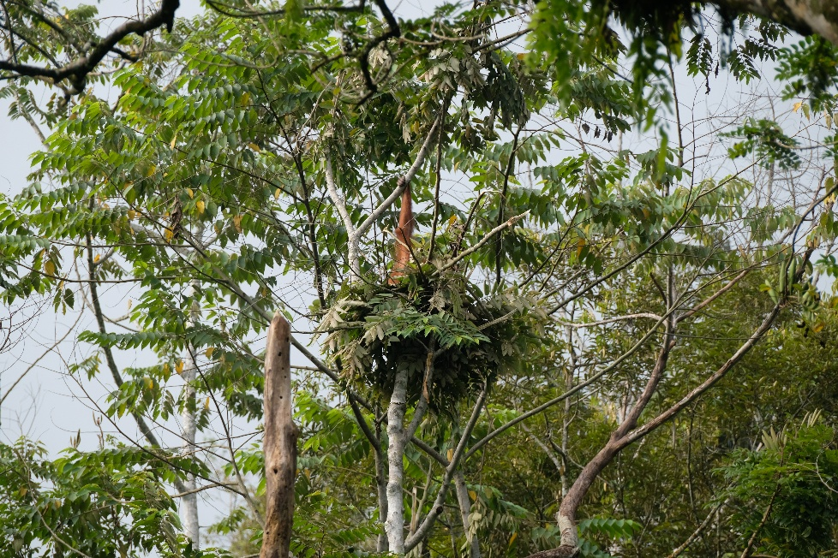
Description picture 2 | Picture 2. Peek-a-boo with Janet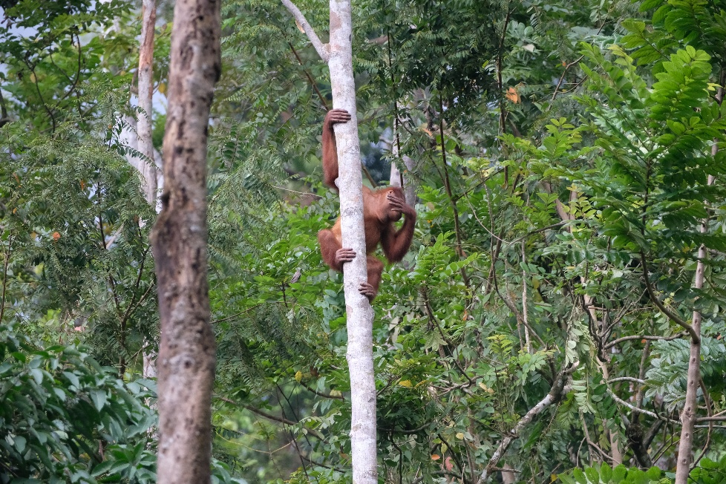
Description picture 3 | Picture 3. OU Janet (top) with her close companion OU Matang (bottom) in the Forest School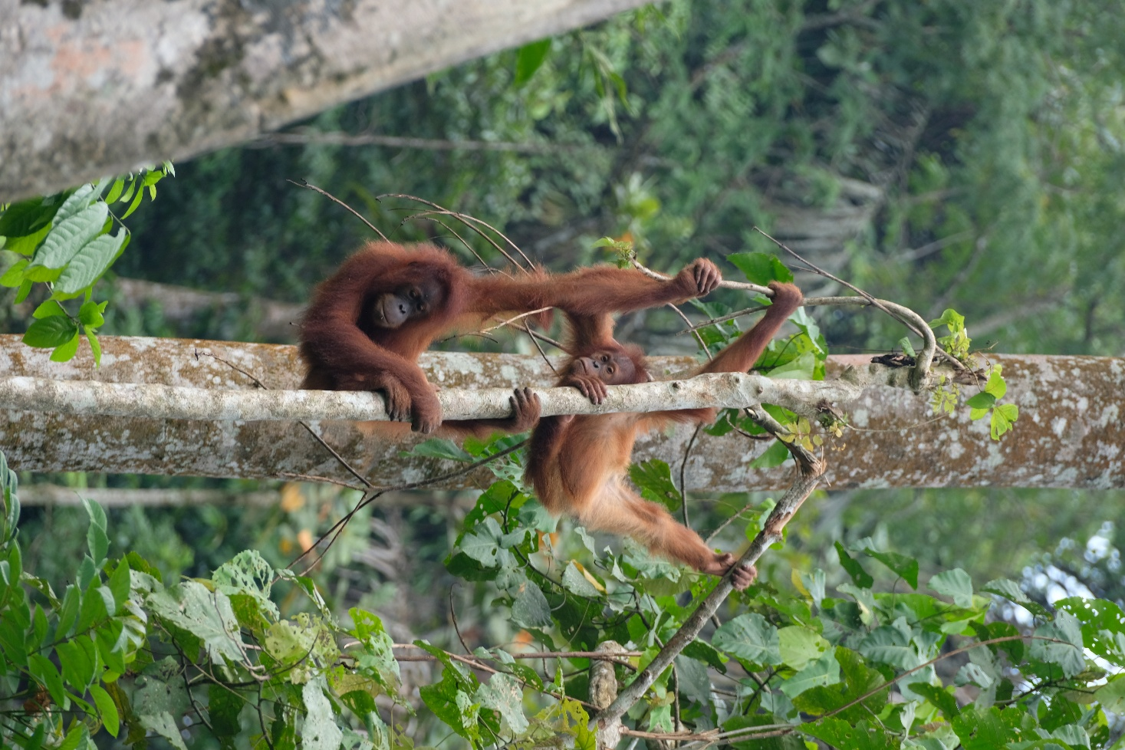
Description picture 4 | Picture 4. OU Janet is highly confident in using canopy branches to travel from one tree to another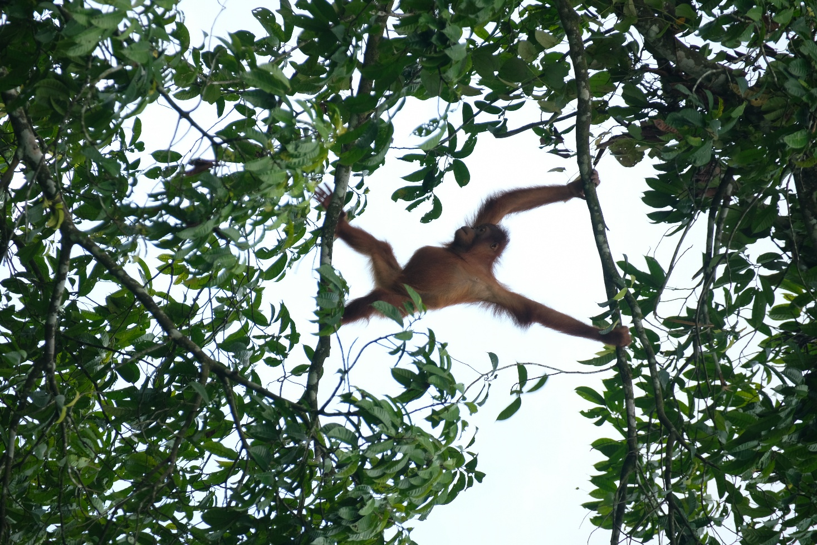
Description picture 5 | Picture 5. Flexible ropes are attached in several locations in the Forest School to encourage arboreal movement in the rehabilitated orangutans. OU Janet knows exactly how to utilize that  