Questionnaire for annual and semi-annual reports.

Name orangutan: Janet

Current housing/cage | Sozialization Cage
Age | 4 Years Old
Current state of health / any particular health issues | Janet is in good health
Progress over the past 6 months | In March, Janet was moved from the temporary infant cage to the socialization cage with four other orangutans (Brenda, Chandra, Matang and Jating).  Since she was first joined with the other orangutans, Janet was often annoyed by Chandra who often stole food and enrichment from her. Because of this, Janet often seeks protection from another orangutan, Brenda. Every time she felt uncomfortable, especially when being annoyed by Chandra, Janet would hug Brenda to seek comfort.  After a few months, Janet began to show her ability to adapt and socialize with other orangutans. Although Chandra still annoyed her, Janet began to deal with the situation bravely and didn't depend on Brenda as much anymore. She began to learn how to avoid Chandra's annoyance. Even when Brenda is not around, Janet no longer feels worried and is able to do her own activities.  As with food, Janet also tries to quickly grab the enrichment or use it to avoid competition with other orangutans. In using enrichment, if a dominant orangutan like Chandra is using a particular enrichment, Janet would likely wait until Chandra finishes using it. Then Janet would use the enrichment.  For leaf enrichment, Janet usually takes just enough. Janet hasn't used it for nest building yet, but still just plays with it or eats it.
Particular events or progress | After being moved to the social cage and joining the social group, Janet was no longer heard crying to get the keeper's attention when the keeper brought food. However, she was still excited when she saw the keeper come with food. Janet has already been shown to be able to focus on getting food and knows how to protect herself and her food to avoid being snatched by other orangutans.  Janet seems to no longer want to be close to humans, and there is no behavior that she makes to seek keeper attention such as crying for attention.  Even when there is human/keeper activity around her she just observes.
Special relationship to any fellow patients (friendships, conflicts, etc.) | When she first joined the social group, Janet was very dependent on Brenda. She felt more comfortable around Brenda, especially when she felt annoyed by Chandra she would hug Brenda.  However, Janet started to adapt to her social environment and showed improvement in socializing independently.

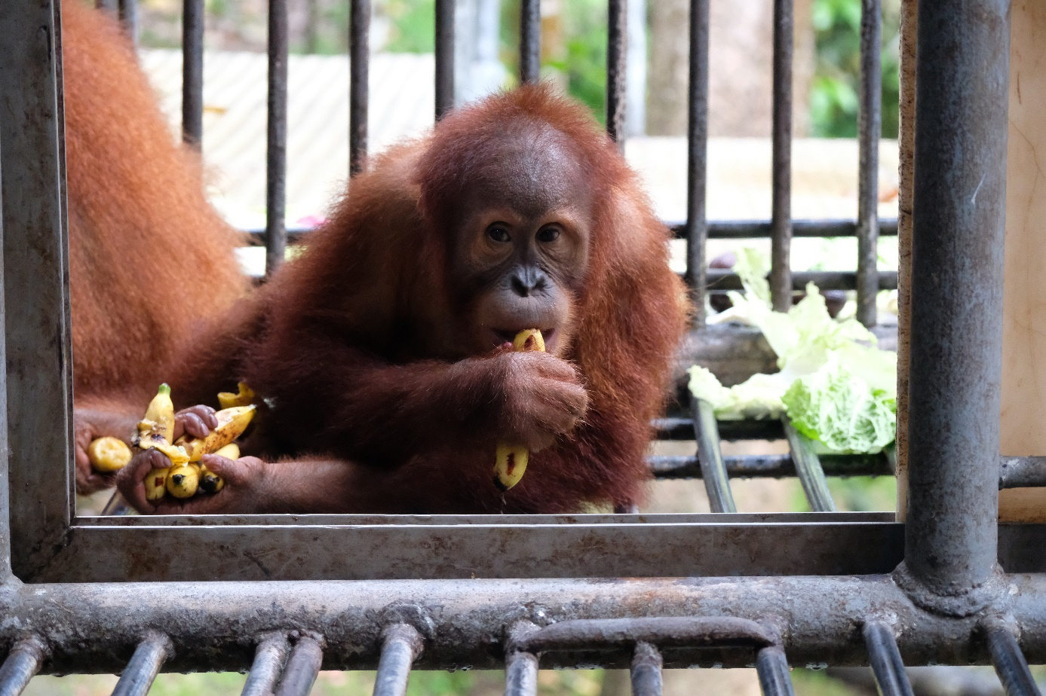
Janet enjoyed her food
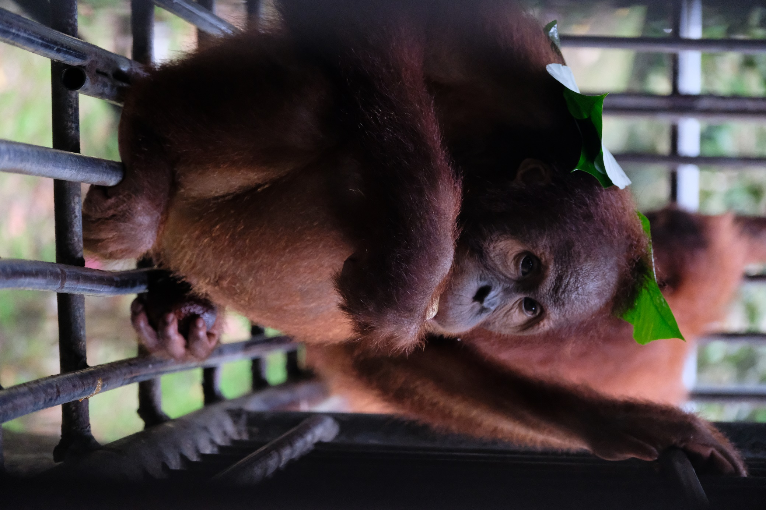 Janet in the cage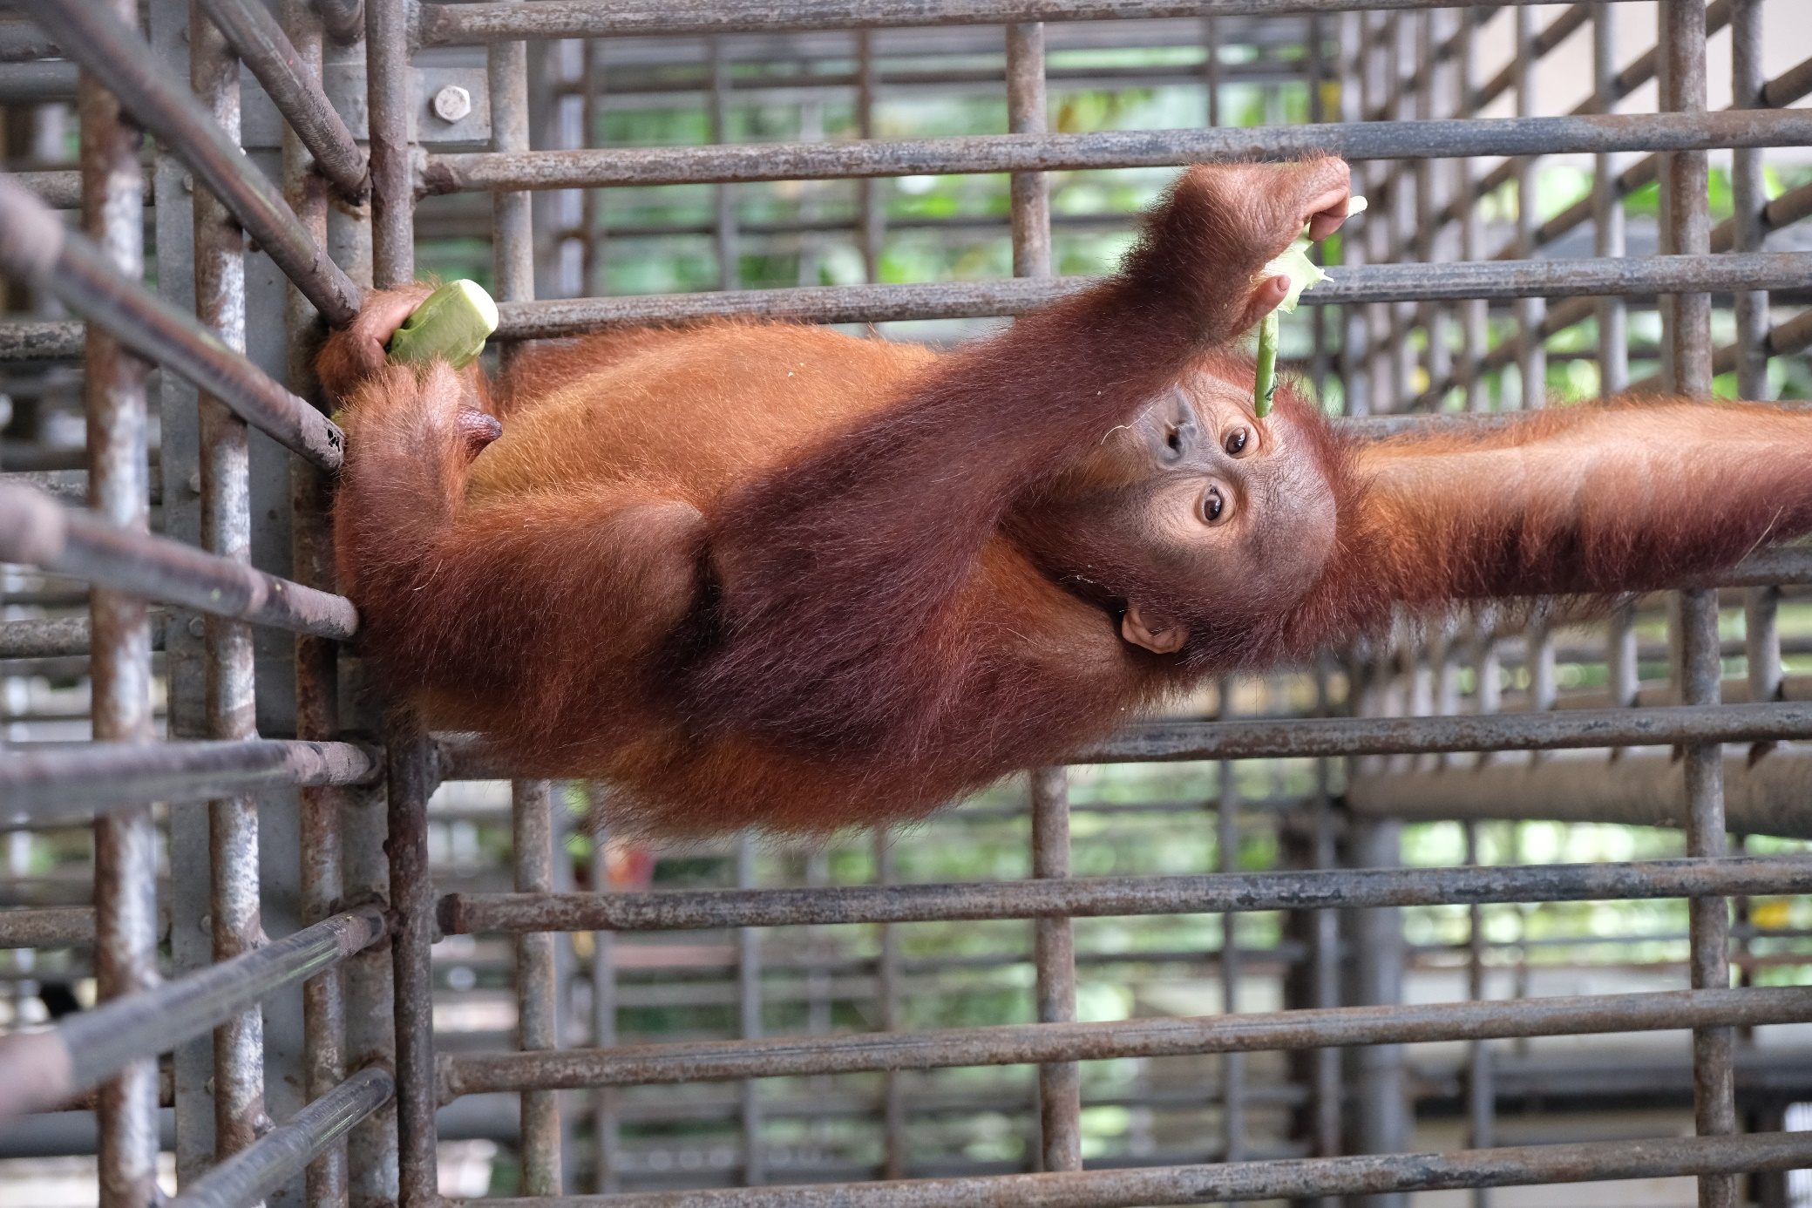Janet in the cage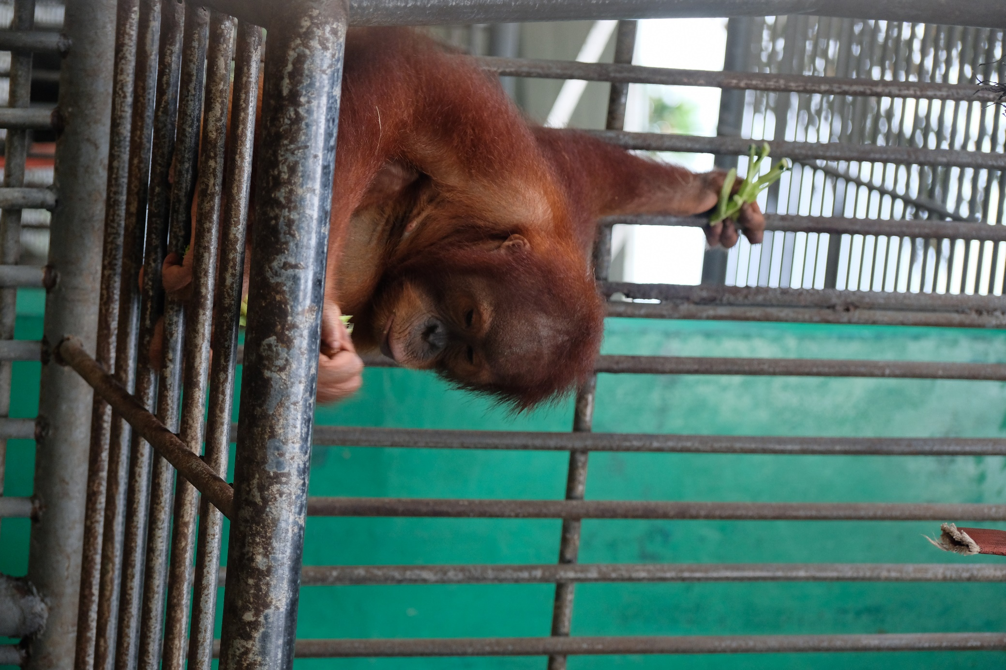Janet in the cage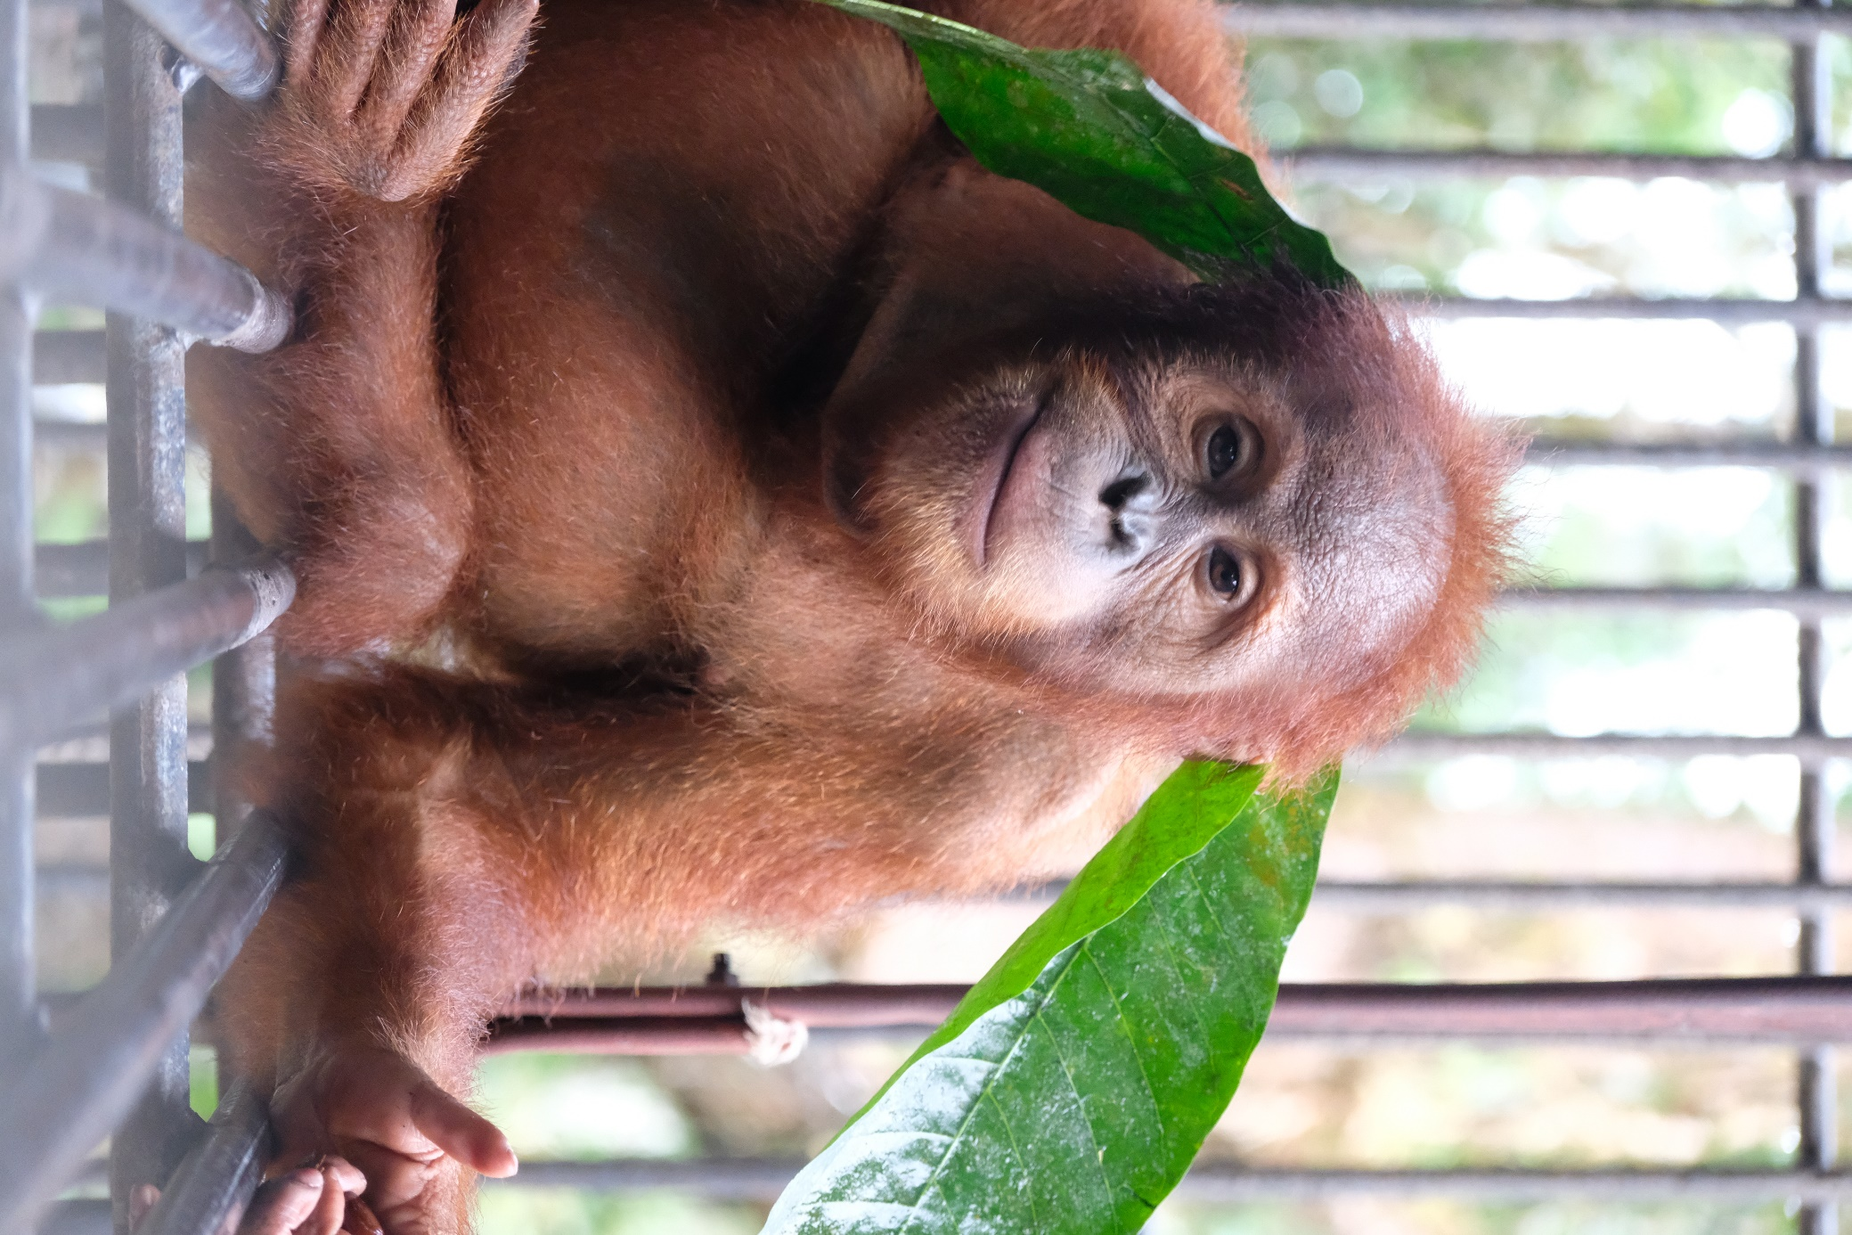Janet with enrichment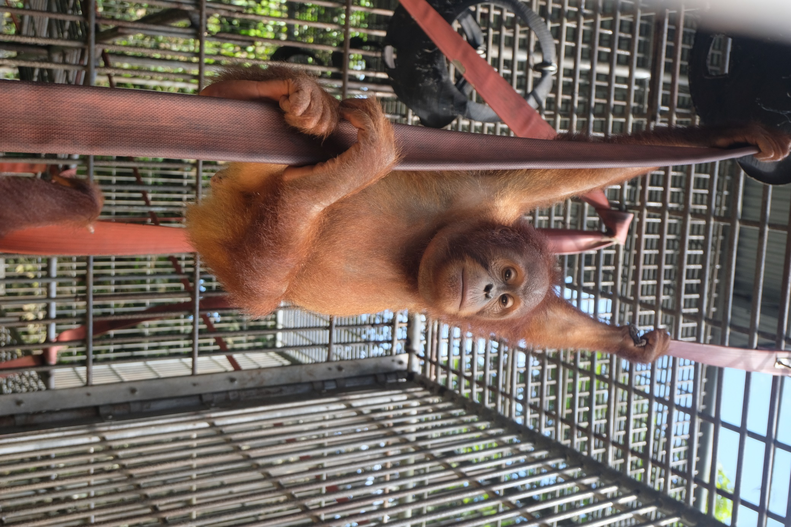Janet with enrichment

