**Profil Janet**

**(March 2025)**

**Background and Current Position**

Janet is an infant female Orangutan (3,5 years old), who was confiscated by the Forestry Officer from Villagers in North Aceh. The information gathered from social media stated that the previous owner found her in their garden after she was bitten by the neighbour’s dog so they kept her to assess her left arm that seemed to be fractured. She was kept for 2 months and was the subject of the villager’s YouTube channel, wearing human clothes and fed with rice.

Janet arrived at SOCP Orangutan Rehabilitation Centre on 30 August 2022 estimated to be 1 year old, in good condition, tame and very familiar with humans. Janet cried and screamed when people disappear from her vision.

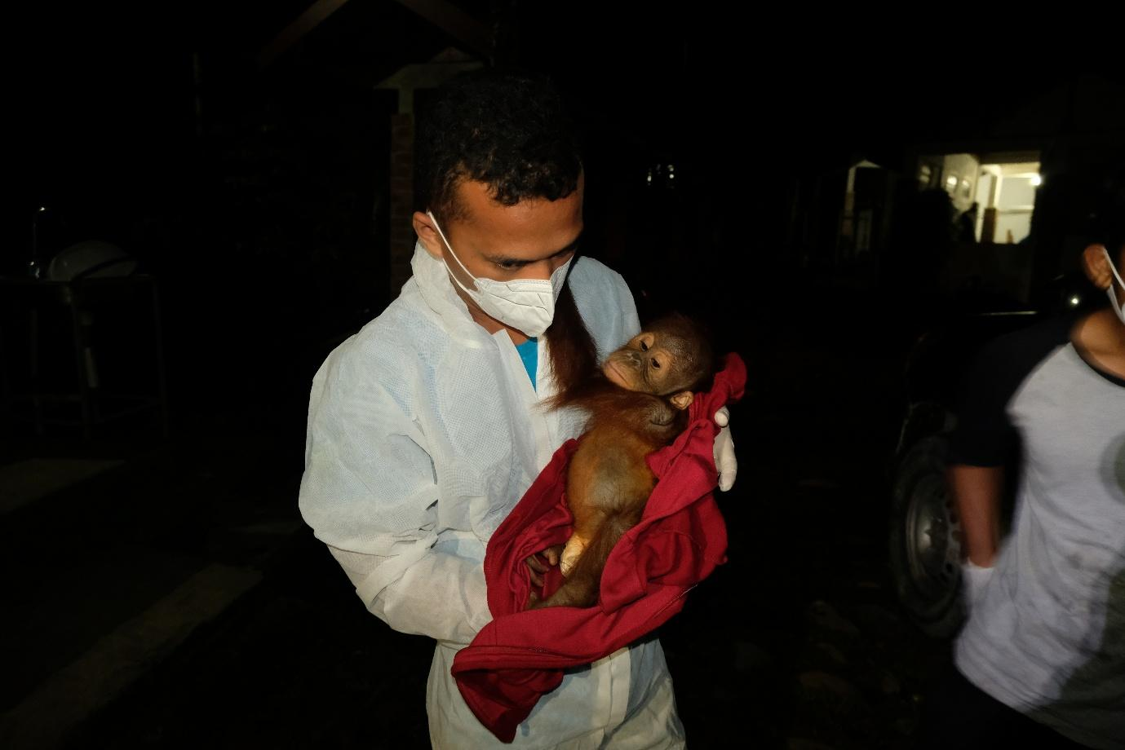

*Pic1. Janet when first arrive at Orangutan SOCP (Photo Arista & Vet Team*

**Behavior and Health**

Janet was very tame and closed to humans when she first arrived at the Centre, Janet ignored almost all kinds of food given b y the keepers. The previous owner said Janet eats white rice daily therefore, the staff still give her a small amount of white rice and slowly change it to fruit and vegetables.

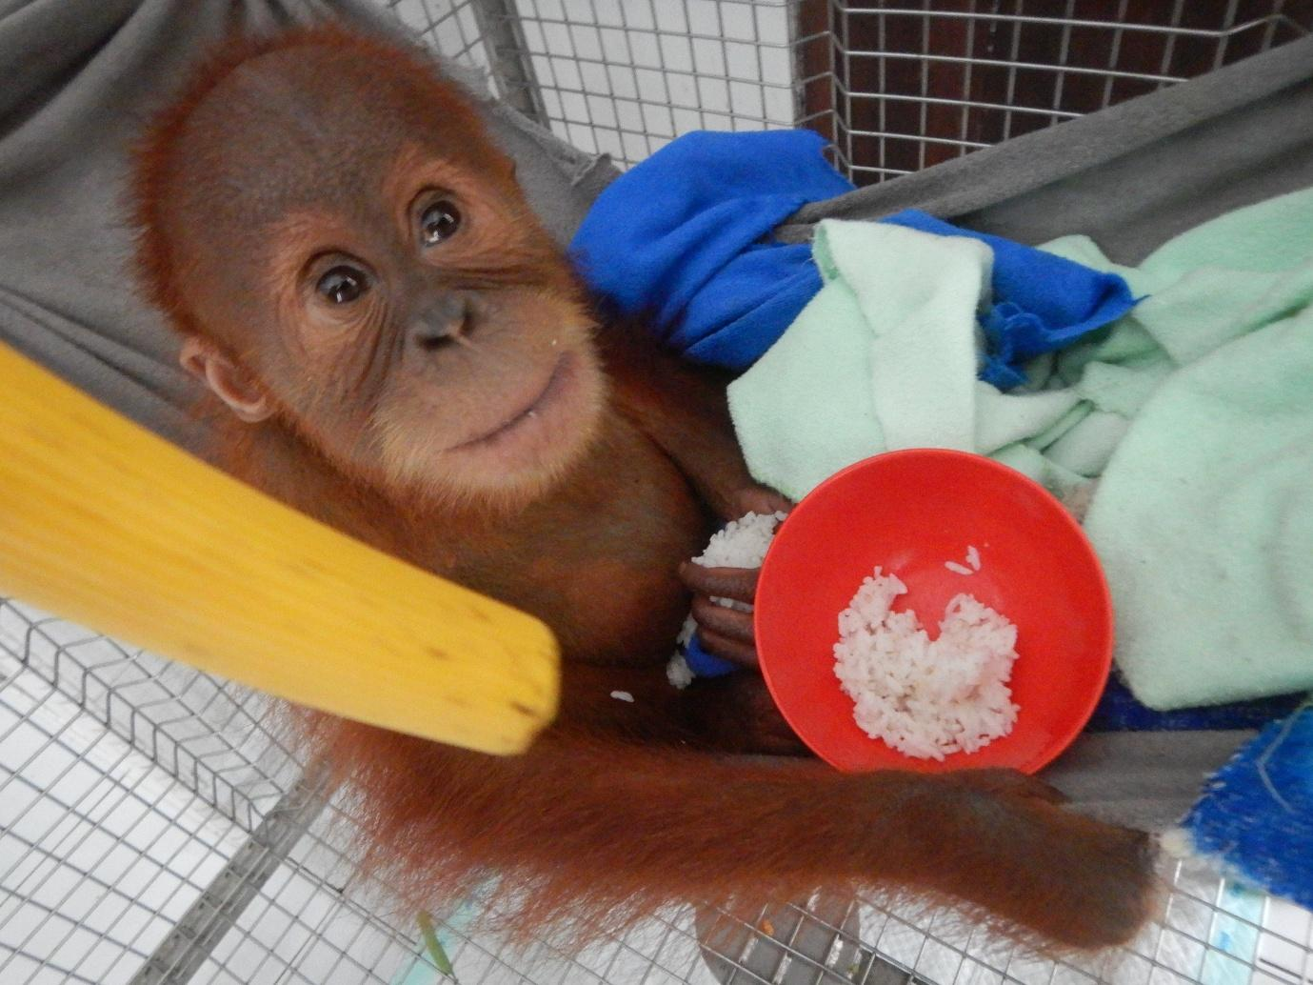

*Pic2. Janet only wants to eat rice, and not eat fruit or vegetables, when she arrived at the SOCP Orangutan Rehabilitation Centre*

Janet underwent Post Quarantine Medical Check on 30th of November 2022, three months after her Pre-Quarantine Medical Check. The medical check included thorax and dental radiographs, in which the chest x-ray showed some abnormalities on the bronchial (bilateral). It was diagnosed that Janet had a respiration illness that she had before arriving at the Centre. Janet showed great progress and her brokenness completely healed. Janet also became a very loud and playful individual.

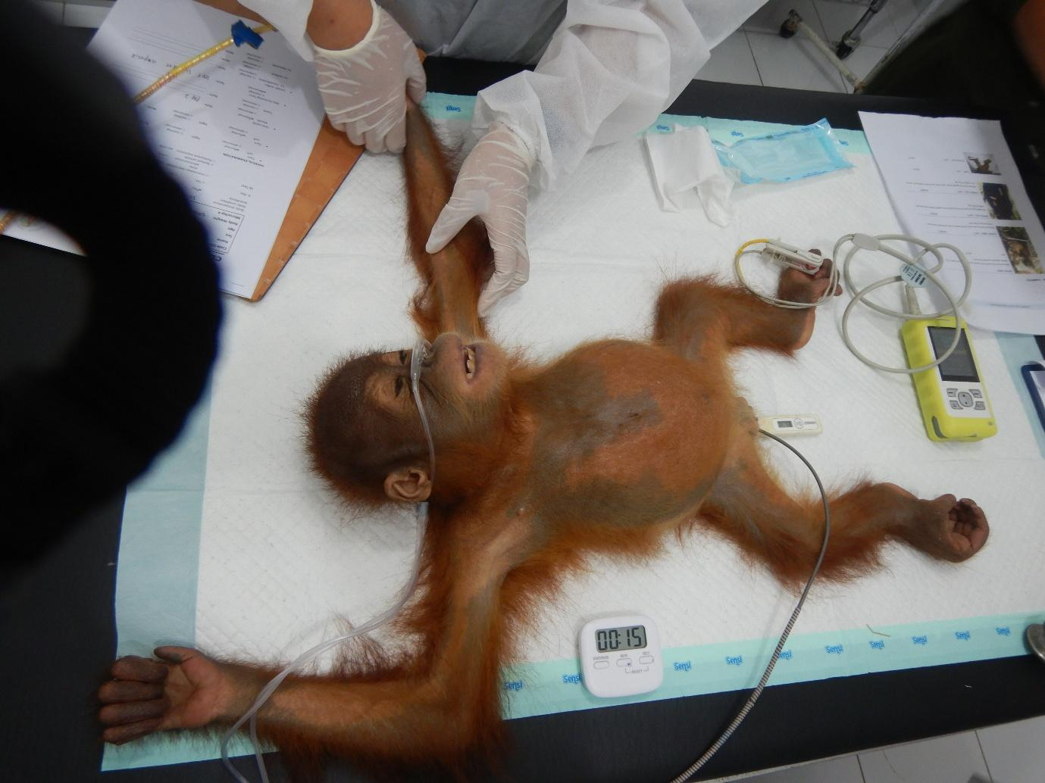

*Pic3. Janet under the Vets treatment (Photo SOCP Vet Team)*

Janet was first reported to have symptoms of upper respiratory tract infection in the first week of November 2022. The symptoms were sneezing and coughing, as well as dried nasal mucus. Janet developed more advanced symptoms, like rough breathing sound, and thickened nasal mucus. At first, the Vets nebulizing therapy and symptomatic drugs. However, her symptoms were not improved therefore the Vets prescribed antibiotics. In mid of December, she showed good health progress, appetite aroused and moved actively in the cage.

After several months at the SOCP Orangutan Rehabilitation Centre Janet looks more independent, not too tame and close to the keeper anymore. She used to give a small amount of white rice but slowly changed to fruits and vegetables. Currently, she eats fruits and vegetables and doesn’t eat rice anymore, though she will prioritize eating fruit first and then vegetables.

June 2023 Janet was placed in a treatment cage because she had diarrhea and needed to be monitored by the medical team and she was still very young. She was joined with other orangutans (Rundah dan Pahae) , the orangutans of similar age to her.

January 2024 showed symptoms of respiratory tract disorders. She was diagnosed had bronchitis thus she was prescribed antibiotics along with symptomatic drugs. She was placed in the Treatment Facility for more intensive health observation. After got intensive care from the medical team she is recovery.

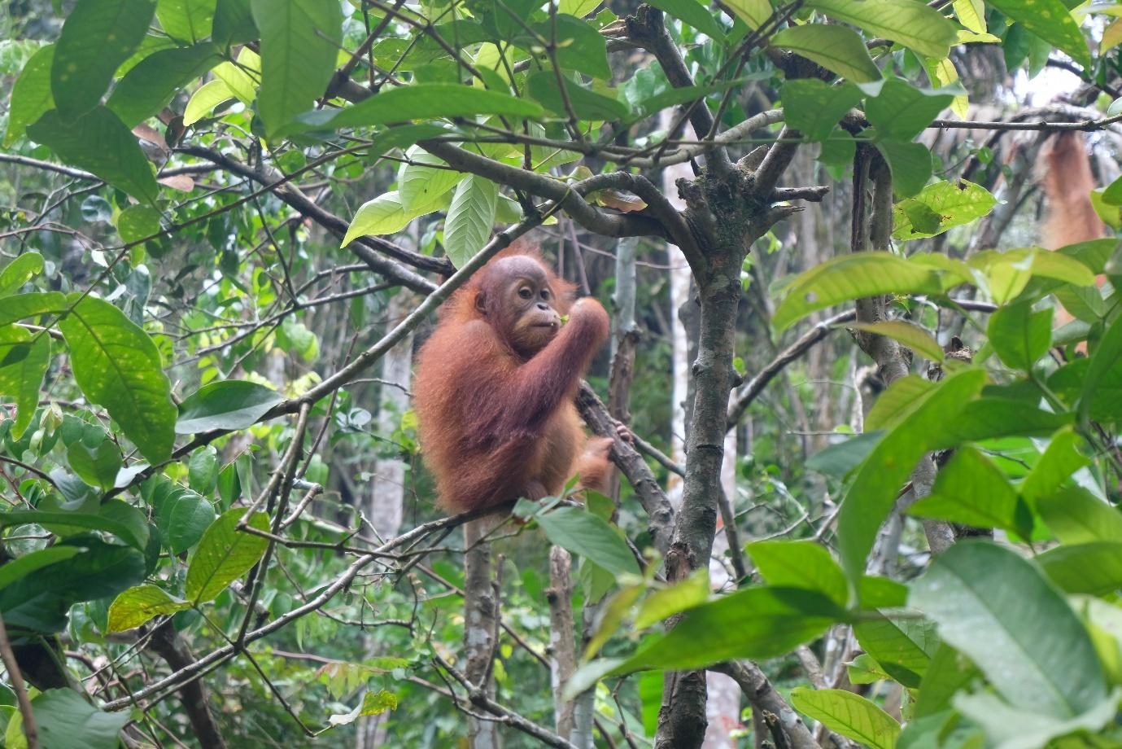

*Pic4. Janet found some young leaves on the tree and tried to eat them*

In 2023 Janet still joined Rundah and Pahae in the treatment cage, and she still looks dominant among them. After that she was placed in the same cage with Natambaru and Digo. Janet is still very interested in the presence of the animal keeper around her. She likes to approach the keeper even though she doesn't try to interact with the keeper but just looks at them and is curious about what the keeper is doing.

Janet is always excited for enrichment activities. Although she has not tried to build a nest yet, she is quite good at enrichment.   Janet was one of the infant orangutans who showed good improvement in her abilities and explored more widely in the Forest School.

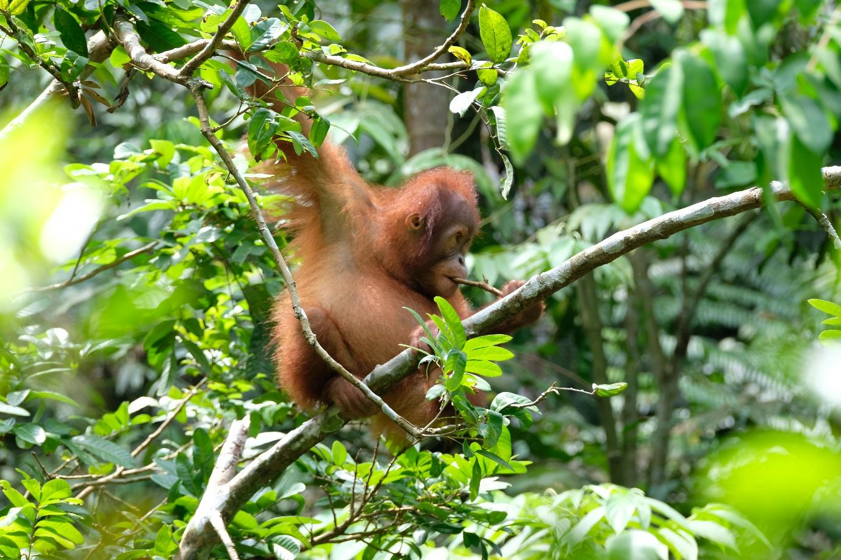

*Pic5. Janet takes a bite out of a small twig in the Forest School*

On 27 November 2024, a devastating landslide struck the Orangutan Quarantine and Rehabilitation Center in the early morning. At the time of the disaster, all orangutans, including Janet, were inside their cages.

The landslide caused significant damage to several facilities at the Center, including the cage, and complete destruction of the Clinic. Another cage affected was Janet's Cage (Infant Facility). The outdoor Infant Facility (used by orangutans during the day) was severely damaged, and the indoor enclosure (used by orangutans at night) also damaged by the landslide material.

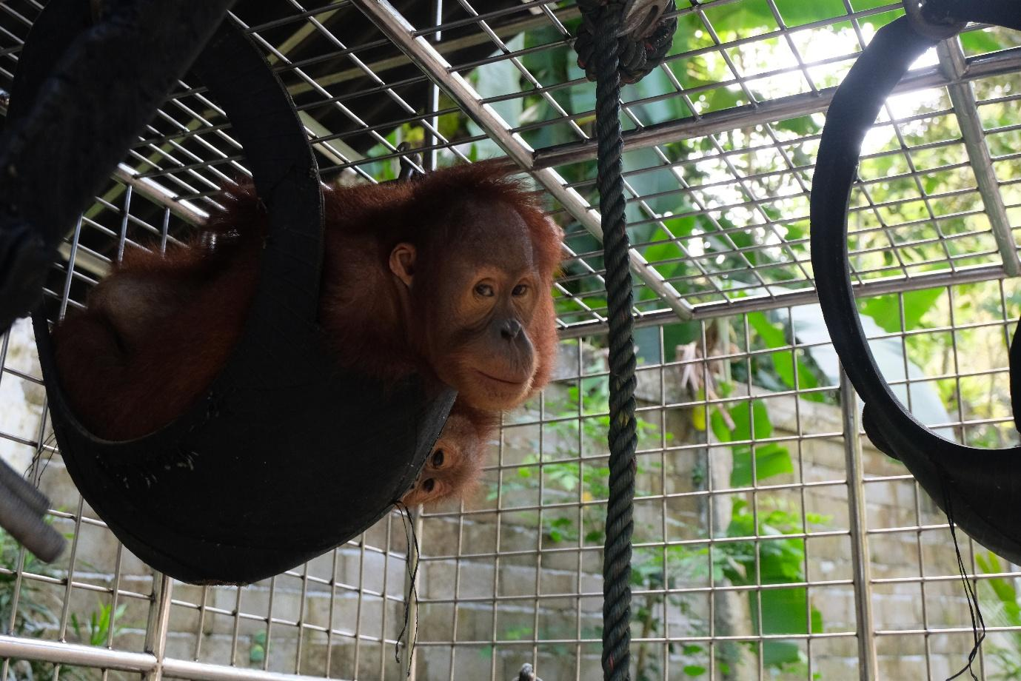

Pic6. Janey plays with the enrichment provided in the cage.

Due to the damage to their cage, Janet and the other orangutans inside were trapped and unable to get out. The keepers had to help them in getting out of the cage and evacuate them to a safer place. Luckily, none of them got injured due to the landslide. Currently, Janet and the other orangutans are placed in the Infant Temporary Cage.

After the landslide, Janet seems to cry whenever she sees the keeper bring food around, which is rarely shown before. It took several days before she could calm down and be more relaxed.